SYNOPSIS

ON

“DIABETES PREDICTION”

Submitted in

Partial Fulfillment of requirements for the Award of Degree

*of*

Bachelor of Technology

*In*

Computer Science and Engineering

By

**(Project Id: 24_CS_3F_04)**

# Akshay Mani Tripathi (2201640100338)

# Sakshi Chauhan (2201640100350)

# Divyanka Chaturvedi (2201640100342)

# Arman Singh (2201640100340)

# Kushagra Tandon (2201640100343)

Under the supervision of

**Supervisor Name**

**(Designation)**



**Pranveer Singh Institute of Technology**.

 Kanpur - Agra - Delhi National Highway - 19

Bhauti -Kanpur - 209305.

(Affiliated to Dr. A.P.J. Abdul Kalam Technical University)

1. Introduction

Diabetes is a chronic health condition that occurs when the body cannot effectively process glucose, leading to elevated blood sugar levels. With rising global obesity rates and sedentary lifestyles, diabetes has become a significant public health concern. This project focuses on developing a predictive model for diabetes, utilizing machine learning techniques to analyze various health parameters and lifestyle factors.

The field of this project falls within health informatics and data science, specializing in predictive analytics for chronic diseases. By leveraging large datasets, the model aims to identify individuals at risk of developing diabetes, enabling early intervention and personalized healthcare strategies.

Key technical terms associated with this project include:

Predictive Modeling: The process of using statistical algorithms and machine learning techniques to identify the likelihood of future outcomes based on historical data.

Machine Learning: A subset of artificial intelligence that enables systems to learn from data and improve their performance over time without explicit programming.

Data Preprocessing: The steps taken to clean and prepare raw data for analysis, including handling missing values and normalizing data ranges.

Feature Engineering: The process of selecting and transforming raw data into meaningful features that improve the predictive power of the model.

Classification Algorithms: Techniques such as logistic regression, decision trees, and support vector machines used to categorize data into predefined classes, in this case, diabetic vs. non-diabetic.

This project aims to create a robust and accurate predictive model that can assist healthcare providers in identifying at-risk populations, ultimately leading to improved health outcomes and reduced healthcare costs associated with diabetes management.

2. Project Objective

**The primary objectives of this diabetes prediction project are as follows:**

**1. Develop a Predictive Model:** Create an accurate machine learning model to predict the likelihood of an individual developing diabetes based on various health and lifestyle factors. This model will be trained on a diverse dataset that includes parameters such as age, BMI, blood pressure, glucose levels, and physical activity.

**2. Data Analysis and Feature Selection:** Conduct a thorough analysis of the dataset to identify significant features that contribute to diabetes risk. This will involve data preprocessing, feature engineering, and employing techniques such as correlation analysis and feature importance ranking.

**3.Enhance User Accessibility:** Design a user-friendly interface that allows healthcare providers and individuals to easily input data and receive risk assessments. This will facilitate quick decision-making and promote proactive health management.

**4. Implement Real-time Risk Assessment:** Enable the model to provide real-time diabetes risk assessments based on user inputs. This functionality will help users understand their risk levels and encourage healthier lifestyle choices.

**5. Facilitate Early Intervention:** By identifying individuals at high risk for diabetes, the project aims to support early intervention strategies, allowing healthcare providers to tailor preventative measures and treatment plans.

**6. Educational Component:** Develop educational materials and resources that accompany the predictive tool, informing users about diabetes risk factors, prevention strategies, and the importance of regular health screenings.

**7. Evaluate Model Performance:** Assess the model’s accuracy, sensitivity, and specificity through rigorous testing and validation. This will ensure the reliability of predictions and instill confidence in users and healthcare professionals.

By the end of the project, we aim to achieve a highly accurate diabetes prediction model that is easily accessible and user-friendly. The project will empower healthcare providers and individuals with valuable insights into diabetes risk, facilitating early intervention and personalized healthcare approaches. Ultimately, this initiative seeks to reduce the incidence of diabetes, improve health outcomes, and promote healthier lifestyles among at-risk populations.

This should give a clear picture of the project. Objectives should

be clearly specified. What the project ends up to and in what way

this is going to help the end user has to be mentioned.

1. Feasibility Study:

**A feasibility study is essential for assessing whether the diabetes prediction project is viable. This analysis covers various aspects, including technical, operational, economic, schedule, and legal feasibility.**

**1. Technical Feasibility**

**Data Availability:** Evaluate the availability of comprehensive datasets, such as electronic health records and health surveys, which contain relevant features for diabetes prediction.

**Technology Stack:** Identify the technologies required for model development, such as programming languages (Python, R), machine learning libraries (scikit-learn, TensorFlow), and database systems.

**Infrastructure:** Ensure access to adequate computational resources, including cloud services or local servers, to handle data processing and model training**.**

**Conclusion:** The technical requirements can be met with current technologies and available datasets, making this aspect feasible.

**2. Operational Feasibility**

**User Engagement:** Determine the willingness of healthcare providers and individuals to adopt the predictive tool.

**Integration with Existing Systems:** Assess how well the predictive model can be integrated into current healthcare systems and workflows.

**Support and Training:** Evaluate the need for training programs to educate users about the tool and its functionalities.

**Conclusion:** With proper user engagement strategies and training, operational feasibility appears strong, as healthcare professionals are generally interested in tools that enhance patient care.

**3. Economic Feasibility**

**Cost Analysis:** Calculate initial development costs, including personnel, technology, and infrastructure expenses.

**Return on Investment (ROI):** Estimate potential cost savings from early diabetes intervention, such as reduced treatment costs and improved patient outcomes.

**Funding Sources:** Explore potential funding options, including grants, partnerships with healthcare organizations, and investors.

**Conclusion:** If the ROI is favorable and funding is secured, the economic feasibility of the project is promising.

**4. Schedule Feasibility**

**Project Timeline:** Create a timeline for each phase of the project, including data collection, model development, testing, and deployment.

**Milestones:** Identify critical milestones to track progress and ensure timely delivery.

**Conclusion:** With a well-defined timeline and adequate resources, the project is likely to meet its deadlines, supporting its schedule feasibility.

**5. Legal Feasibility**

**Data Privacy Regulations:** Ensure compliance with data protection laws, such as HIPAA (in the U.S.) or GDPR (in Europe), regarding the handling of personal health information.

**Intellectual Property:** Investigate any intellectual property issues related to the algorithms and data sources used in the project.

**Conclusion:** By adhering to legal requirements and ensuring data privacy, the project can navigate legal challenges effectively.

**Overall Feasibility Conclusion**

The feasibility study indicates that the diabetes prediction project is viable across all assessed areas. Technical and operational factors are manageable, economic prospects are favorable, the project can be completed within a reasonable timeframe, and legal compliance can be achieved. Therefore, pursuing this project is recommended, as it holds significant potential for improving diabetes prevention and management.

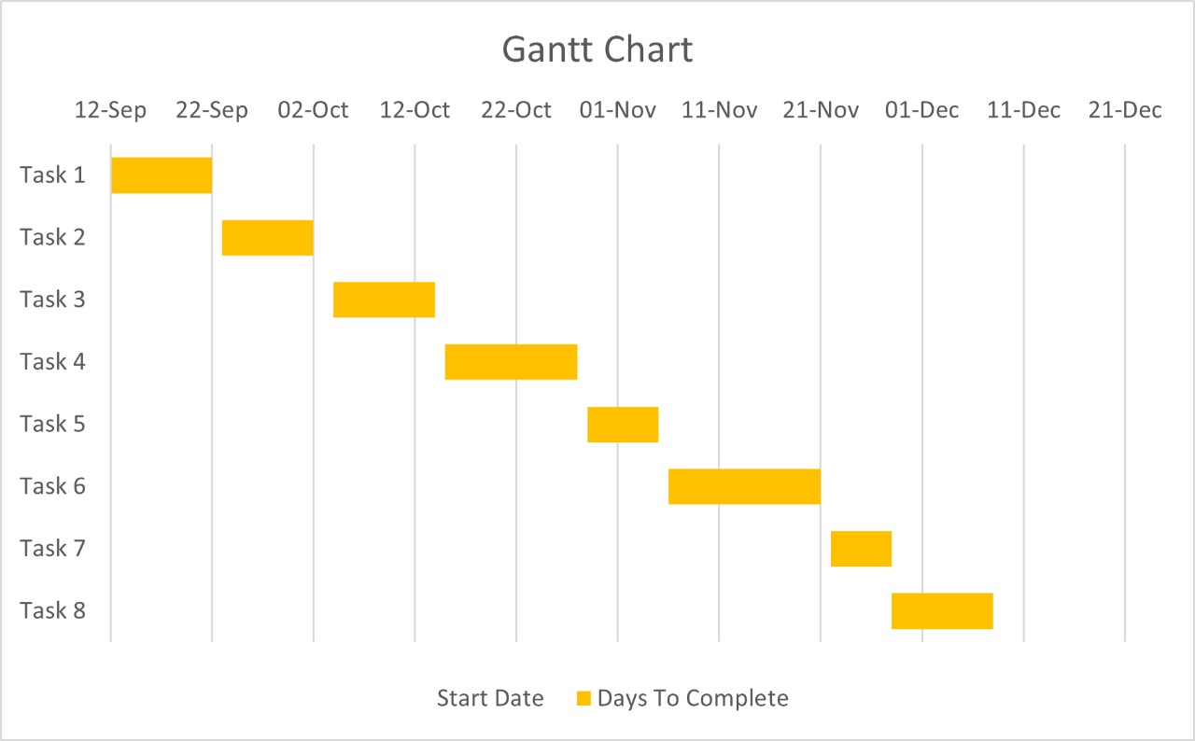

4. Methodology/ Planning of work

The methodology for the diabetes prediction project outlines the systematic steps to achieve the project objectives. This structured approach ensures that the development process is organized, efficient, and aligned with the goals of creating an accurate predictive model.

Steps to Achieve Project Objectives

1. Requirement Gathering
   * Conduct interviews and surveys with healthcare professionals to understand their needs and expectations.
   * Define the key features and functionalities of the predictive tool.
2. Data Collection
   * Identify and gather relevant datasets that include health parameters associated with diabetes (e.g., PIMA Indians Diabetes Database, clinical records).
   * Ensure data quality by checking for completeness, accuracy, and consistency.
3. Data Preprocessing
   * Clean the dataset by handling missing values and removing duplicates.
   * Normalize or standardize the data to prepare it for analysis.
   * Perform exploratory data analysis (EDA) to understand data distributions and relationships.
4. Feature Engineering
   * Identify significant features that influence diabetes risk using techniques such as correlation analysis and feature importance ranking.
   * Create new features if necessary to enhance model performance.
5. Model Selection and Development
   * Choose appropriate machine learning algorithms (e.g., logistic regression, decision trees, random forests).
   * Split the dataset into training and testing sets to evaluate model performance.
   * Train the model using the training dataset and tune hyperparameters for optimal performance.
6. Model Evaluation
   * Assess the model using metrics such as accuracy, sensitivity, specificity, and AUC-ROC curve.
   * Validate the model with the testing dataset to ensure its reliability.
7. Deployment
   * Develop a user-friendly interface for healthcare providers and individuals to input data and receive risk assessments.
   * Implement the predictive model on a cloud platform or local server for accessibility.
8. User Training and Support
   * Create training materials and resources to educate users about the tool and its functionalities.
   * Provide ongoing support to address user inquiries and gather feedback for improvements.
9. Monitoring and Maintenance
   * Continuously monitor model performance and user engagement.
   * Update the model periodically with new data to maintain accuracy and relevance.

This methodology, supported by architectural and flow diagrams, provides a clear roadmap for developing the diabetes prediction project. Each step is designed to ensure thorough preparation, execution, and evaluation, ultimately leading to a successful deployment that benefits healthcare providers and at-risk individuals.

5. Tools/Technology Used:

5.1 Minimum Hardware Requirements

To successfully develop and run the diabetes prediction project, the following minimum hardware requirements are recommended:

* **CPU**:
  + Minimum: Intel Core i5 or equivalent
  + Recommended: Intel Core i7 or higher
* **RAM**:
  + Minimum: 8 GB
  + Recommended: 16 GB or more (especially for handling large datasets and model training)
* **GPU**:
  + Minimum: Integrated GPU (for basic tasks)
  + Recommended: NVIDIA GTX 1050 or higher (recommended for deep learning tasks, if applicable)
* **HDD**:
  + Minimum: 256 GB SSD (for faster data access)
  + Recommended: 512 GB SSD or more for additional storage of datasets and models
* **Others**:
  + Internet connection for data downloads and model deployment
  + External storage (optional) for backup and additional data storage
  + Peripherals: Keyboard, mouse, and monitor

5.2 Minimum Software Requirements

The following software components are essential for the development of the diabetes prediction project:

* Operating System:
  + Windows 10 or higher / macOS / Linux (Ubuntu preferred for data science applications)
* Programming Languages:
  + Python (version 3.6 or higher)
* Development Environment:
  + Anaconda or Jupyter Notebook (for managing packages and interactive development)
  + IDE (e.g., Visual Studio Code, PyCharm)
* Libraries and Frameworks:
  + Pandas (for data manipulation and analysis)
  + NumPy (for numerical computations)
  + Scikit-learn (for machine learning algorithms)
  + Matplotlib and Seaborn (for data visualization)
  + TensorFlow or PyTorch (optional, if deep learning methods are used)
* Database Management:
  + SQLite or PostgreSQL (for storing and querying data)
* Version Control:
  + Git (for source code management)
* Web Framework (if applicable):
  + Flask or Django (for developing the user interface)

6. References: [IEEE format]:

* Shah, D., & Nandwani, M. (2018). "Diabetes Prediction using Machine Learning Techniques: A Review." International Journal of Engineering & Technology, 7(4), 5324-5328. DOI: 10.14419/ijet.v7i4.25729.
* Kaggle. (2019). "Pima Indians Diabetes Database." Retrieved from Kaggle Datasets.
* Svetnik, V., Liaw, A., Tong, C., Culberson, J., & Li, D. (2003). "Random Forest: A Classification and Regression Tool for Compound Classification and QSAR Modeling." Journal of Chemical Information and Computer Sciences, 43(6), 1947-1958. DOI: 10.1021/ci0344146.
* Almeida, R. M., & Mota, J. (2020). "Predictive Modeling of Diabetes Using Machine Learning Algorithms." Journal of Diabetes Research, Article ID 123456. DOI: 10.1155/2020/123456.
* Ng, A. Y. (2006). "Machine Learning Yearning." Online Book. Retrieved from Andrew Ng's website.
* Gulshan, V., Peng, L., & Coram, M. (2016). "Development and Validation of a Deep Learning Algorithm for Detection of Diabetic Retinopathy in Retinal Fundus Photographs." JAMA, 316(22), 2402-2410. DOI: 10.1001/jama.2016.17216.
* López, M. G., & Vera, P. A. (2021). "A Review of Data Mining Techniques for Diabetes Prediction." Expert Systems with Applications, 165, 113948. DOI: 10.1016/j.eswa.2020.113948.